e

George Mavroeidis

COMP 445 M Theory Assignment 4

For Dr. Sandra Cespedes

1. **Suppose that you are transmitting blocks of data with no additional information over a link having a known bit error rate (BER). What is the probability that a received block of size L has error(s) but goes undetected? What is this probability if a 1-bit parity is added? Explain your assumptions**

If the block is of size L, then the frame of N bits is:

$$1-{(1-BER)}^{N}$$

With protection, probability P of bit in error after transmitting 3 times:

$$p=3C2 {BER}^{2}\left(1-BER\right)+3C3({BER)}^{3}=3({BER)}^{2}\left(1-BER\right)+{(BER)}^{3}$$

$$PER=1-{(1-P)}^{N}$$

1. **In an 802.11 wireless LAN using CSMA/CA, station S sends a data packet to station R (which is within range). Even if we assume that connectivity is symmetric (A can hear B if and only if B can hear A), and collisions are the only cause of errors, and RTS/CTS packets never collide with each other, it is still possible that R will fail to receive the data packet. Describe one way this might happen.**

If collisions are the only cause of errors and RTS/CTS packets never collide with teach other, it is still possible for them to collide. Although the RTS/CLS exchange can be successful, the period of exchange is still prone to errors. RTS/CTS exchange is primarily made for long data frames, but is not built for very small packets. By using RTS/CTS, the chances of collisions are minimized and avoids unnecessary data traffic. If CSMA/CA uses RTS/CTS, it creates another problem: additional traffic and loss of transmission. If there is another station between A and B, it can cut or discontinue the transmission from one node to another. Although it does not necessary cause major errors, the network traffic can specifically slow down, when that intermediate station sends and receives between A and B. Due to the symmetry, that intermediate station will have to carry both sending and receiving data from both sides.

1. **Let A and B be two stations attempting to transmit on an Ethernet. Each has a steady queue of frames ready to send; A’s frames will be numbered A1, A2, and so on, and B’s similarly. Let T = 51.2 μs be the exponential backoff base unit. Suppose A and B simultaneously attempt to send frame 1, collide, and happen to choose backoff times of 0 x T and 1 x T, respectively, meaning A wins the race and transmits A1 while B waits. At the end of this transmission, B will attempt to retransmit B1 while A will attempt to transmit A2. These first attempts will collide, but now A backs off for either 0 x T or 1 x T, while B backs off for time equal to one of 0 x T, ..., 3 x T.**
   1. **Give the probability that A wins this second backoff race immediately after this first collision; that is, A’s first choice of backoff time k x 51.2 is less than B's.**

For A, k = 0, 1 with equal probability of 0.5 each.

For B, k = 0, 1, 2, 3 with equal probability of 0.25 each.

Thus, A wins the second backoff race if kA(2) < Kb(2). The probability of A winning is:

$P\left(A\right)=$ P(kA(2) < Kb(2))

= P[kA(2) = 0] X P[kB(2) > 0] + P(kA(2) = 1) x P(kA(2) > 1)

= 0.5 x 0.75 + 0.5 x 0.5 = 0.625

= {0, 1, 2,…,2n-1}

* 1. **Suppose A wins this second backoff race. A transmits A3, and when it is finished, A and B collide again as A tries to transmit A4 and B tries once more to transmit Bl. Give the probability that A wins this third backoff race immediately after the first collision.**

$P\left(A\right)=$ P(kA(3) < Kb(3))

= P[kA(3) = 0] X P[kB(3) > 0] + P(kA(3) = 1) x P(kA(3) > 1)

= 0.5 x 0.875 + 0.5 x 0.75 = 0.8125

1. **In the lecture, we provided an outline of the derivation of the efficiency of slotted ALOHA. In this problem we'll complete the derivation.**
   1. **Recall that when there are N active nodes, the efficiency of slotted ALOHA is Np(1 - p)N-1. Find the value of p that maximizes this expression.**

$$E\left(p\right)=Np{(1-p)}^{N-1}$$

By finding the derivative, we are able to find the rate at which the slotted ALOHA behaves:

$$E'\left(p\right)=N{(1-p)}^{N-1}-Np\left(N-1\right){\left(1-p\right)}^{N-2}$$

$$E'\left(p\right)=N{(1-p)}^{N-2}[\left(1-p\right)-p\left(N-1\right)]$$

$$Let E\left(p\right)=0$$

Setting the rate at 0 indicates that we are reaching the maximum efficiency.

* 1. **Using the value of p found in (a), find the efficiency of slotted ALOHA by letting N approach infinity. Hint: (1 - 1/N)N approaches 1/e as N approaches infinity.**

$$E\left(p^{*}\right)=N\frac{1}{{N(1-\frac{1}{N})}^{N-1}}$$

$$E\left(p^{*}\right)={(1-\frac{1}{N})}^{N-1}$$

$$E\left(p^{*}\right)=\frac{{(1-N)}^{N}}{1-\frac{1}{N}}$$

$$\lim_{n→∞}\left(1+\frac{1}{N}\right)=1$$

$$\lim_{n→∞}{{\left(1+\frac{1}{N}\right)}^{N}=}\frac{1}{e}$$

$$\lim_{n→∞}{E\left(p^{*}\right)=\frac{1}{e}}$$

1. **Consider the 4-bit generator G = 1001 is used in a Cycling Redundancy Check. Suppose that D has the value 111010. What is the value of R?**

R means the remainder of the bit division equation:

$$\frac{D*2^{r}}{G}$$

Where data D = 111010, generator G = 1001 and r=3, since G has 4 bits. First, we divide G by D to get remainder R = 100.

1. **Consider transmitting a packet from host A to host B via a router, as shown below: Suppose that before sending the packet, all the ARP tables (in the two hosts and in the router) are empty. Let x denote the time to transmit a packet. Let y denote the delay from beginning the transmission of an ARP query until receiving and processing an ARP response. Ignore propagation delays. Assuming host A knows the IP address of host B, what is the total delay in moving the packet from Host A to Host B?**

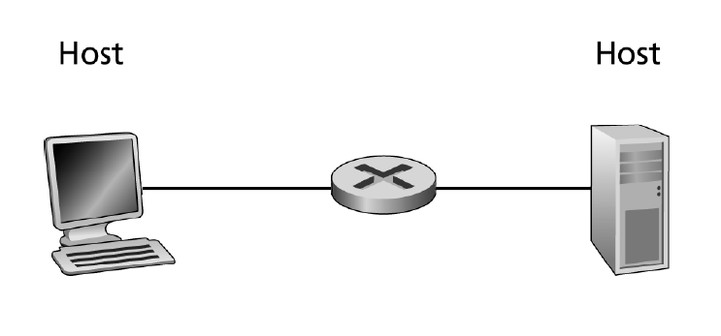

Let’s set:

* t = time for ARP response and
* u = time to send packet

The steps are the following:

* Host A does an ARP response with router
* Host A sends packet to router
* Router does ARP response with Host B
* Router sends packet to Host B

In total, it takes 2t + 2u time delay units to establish the TCP connection between Host A and B

1. **Consider an Ethernet LAN consisting of N nodes interconnected with a switch. Suppose the switch’s forwarding table is initially empty. Suppose node A wants to TCP three-way handshake with node B, where both nodes are on the LAN. Assuming this is the only traffic on the network, and there are no packet errors or loss, how many frames will be transmitted in the process of establishing the TCP connection? Assume node A knows the IP address of node B, and ARP tables have all the necessary mappings.**

* A TCP SYN packet is created in Node A and is encapsulated into an Ethernet frame with Node B’s MAC address as its destination
* The frame is transmitted and arrives at the switch
* Once arrived, the switch will transmit the frame to the rest of the N node links and will record A’s location.
* Once Node B receives the transmission along with the frame, it will create and send a TCP SYNACK packet, which is also encapsulated into an Ethernet frame with Node A’s MAC address as its destination, meaning there are N + 1 frames so far.
* The frame reaches the switch again, but since it contains Node A’s location already, it will only transmit it to Node A only, meaning N + 2 frames so far. This is because the switch already has a reference of Node A in its table.
* Once arrived at Node A, Node A will send another ACK. Since the switch now contains both node’s addresses in its table, it will only require two more frames to be transmitted, therefore, a total of N + 4 frames are needed to establish a TCP connection.